# Lab: Apache configuration for Linux (Debian-based distros)

This **tutorial** provides step-by-step guidelines to setup your Apache environment. You will learn how to configure your web server. There will be a good explanation on how to run **java** programs powered by **CGI scripts** in order to process HTTP requests.

## Apache environment

#### Setup

Install Apache HTTPD Server. On a Debian based distribution you can do it by the following command:

|  |
| --- |
| **sudo apt-get install apache2** |

#### Settings

1. Enable CGI Scripts  
   Go to **etc/apache2/sites-enabled/000-default.conf** and the following lines within **<Virtual Host>** directive.

|  |
| --- |
| **000-default.conf** |
| **<Virtual Host>**  **…**  ScriptAlias **/cgi/ /var/www/cgi/**  <Directory **"/var/www/cgi**">  AllowOverride None  Options **+ExecCGI** -MultiViews +SymLinksIfOwnerMatch  Order allow,deny  Allow from all  </Directory>  …  **</Virtual Host>** |

Then go to **/var/www/** and create a folder **cgi**. There will be your cgi scripts.

Write in the terminal: **sudo a2enmod cgi** This will enable the cgi module.

|  |
| --- |
| **sudo a2enmod cgi** |

Then restart the server with **sudo apachectl restart**

|  |
| --- |
| **sudo apachectl restart** |

1. Port setup
   1. **etc/apache2/ports.conf**
   2. Find **Listen 80** in the configuration file.
   3. Open the terminal type **sudo netstat –peanut**

|  |
| --- |
| **sudo netstat –peanut** |

* 1. If port 80 is taken change to another free one

## Server start

By default, the web server should be running. If not start it with the following command:

sudo apachectl start

If everything is fine you should see a simple web page when you enter localhost: {**YOUR_PORT**}. For example, my port is 80 and when I type localhost:80 in the browser I receive the following output:

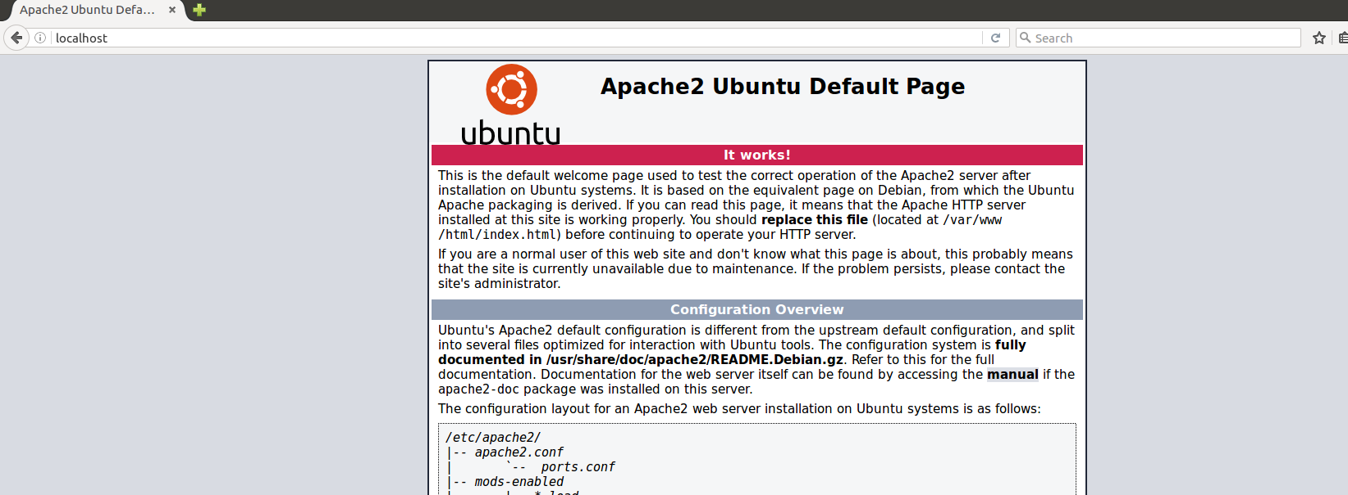

## First java program

Write a simple java program that prints some text. For Example:

|  |
| --- |
| **Test.java** |
| **package** cgi;  **public class** Test {  **public static void** main(String[] args) {  String type = **"Content-Type: text/html\n\n"**;  String output =  **"<html>"** +  **"<body>"** +  **"<b>"** +  **"Hello from CGI!"** +  **"</b>"** +  **"</body>"** +  **"</html>"**;  System.***out***.println(type);  System.***out***.println(output);  } } |

Before we print anything we need to set the type of the page. In our case this is HTML. So we **must** print the content type first **"Content-Type: text/html\n\n"**

Copy the **.java** file and paste it to **/var/www/cgi** Open it with notepad editor and remove the package. In my example I should remove **package** cgi;

In **/var/www/cgi** start the terminal and create a .class of our program by typing **javac Test.java**

|  |
| --- |
| **javac Test.java** |

After you have a Test.class we need **a CGI script to invoke our java program.** So create a file called **invoker.sh** in **/var/www/cgi** with the following lines:

|  |
| --- |
| **invoker.cgi** |
| **#!/bin/sh**  **java Test** |

The first line determines the interpreter which will execute the script. The second line will execute our java program. At the end you should execute this URL: http://localhost: {**PORT**}/cgi/invoker.cgi

